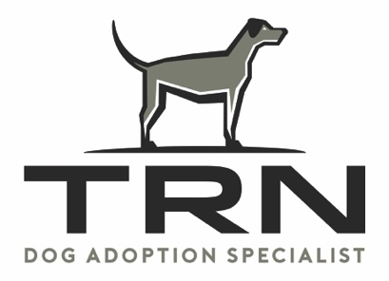

Rescue Social Media/Adoption Application

Date________________
Rescue Organization Name: _____________________________________
501 (C)(3):_____________________
Rescue Organization Website:______________________________________
Rescue Organization Facebook address:_________________________
Contact Name:_________________________Cell:______________Email:___________________
Terms of Agreement
Once your rescue has filled out the TRN application above and been approved by TRN you will need to complete the following:
- Submit a picture and bio of each dog you would like advertised on the TRN Facebook page. Please send the info to celeste@tucsonrescuenow.com
- For photos we need a great head shot and a full body shot of your dog/dogs.
- Bio should include as much of the dog's history as possible. Of particular importance is, have they lived with other dogs, cats or children and if not, are they good with dogs, cats and children? Any behavioral issues must be fully disclosed.
- Must have complete updated medical records including shots, from veterinary. State if dog has been spayed or neutered.
- When we have all this information we will schedule a time for you to come into the TRN Adoption Store so we can meet your dog /dogs.
- After this TRN will schedule days and times with the foster to bring the dog in to the store as customer requests come in on a weekly basis.

In Store Guidelines
- The foster must stay with the dog so they can answer customer questions and make sure the dog is comfortable in the store surrounding.
- If the adoption takes place in the store TRN will collect a donation fee of a min of $100.00 from the adopter.
- If the dog is adopted outside the store, but was because of the TRN Facebook advertising we would ask rescue for a donation of $50.00
We are a 501 (c)(3) completely funded by donations only. Our goal at TRN is to find perfect environments and loving homes for senior dogs.
SIGNED BY:______________________________________________DATE:________________________

